**SQL Assignment No 1**

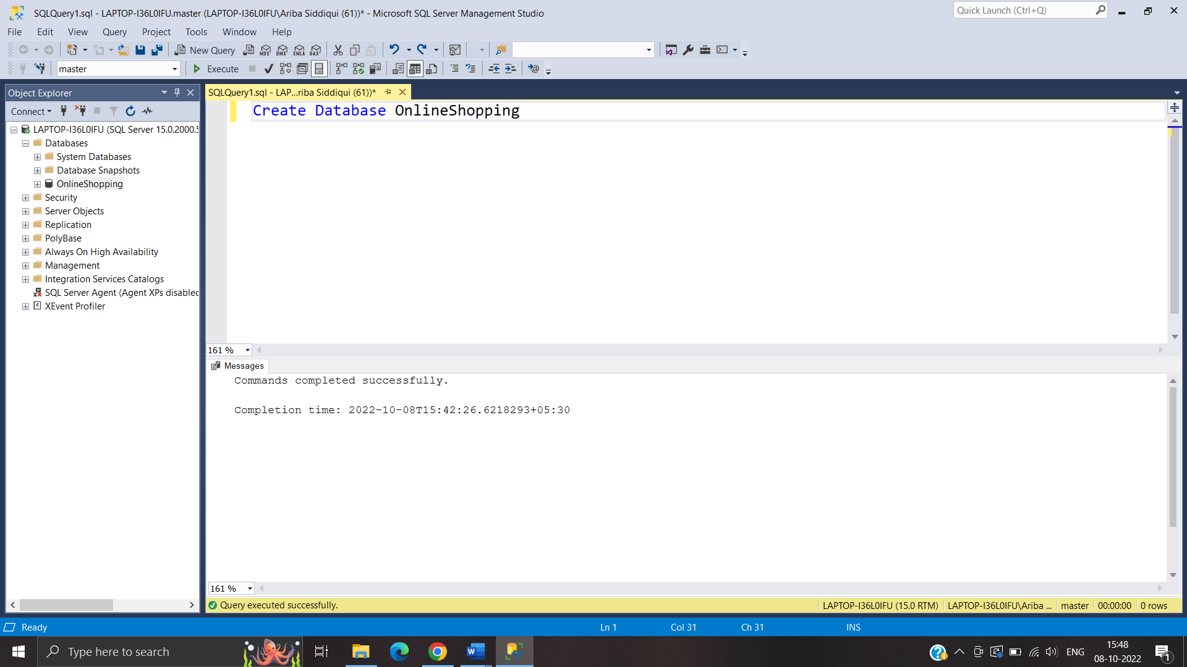

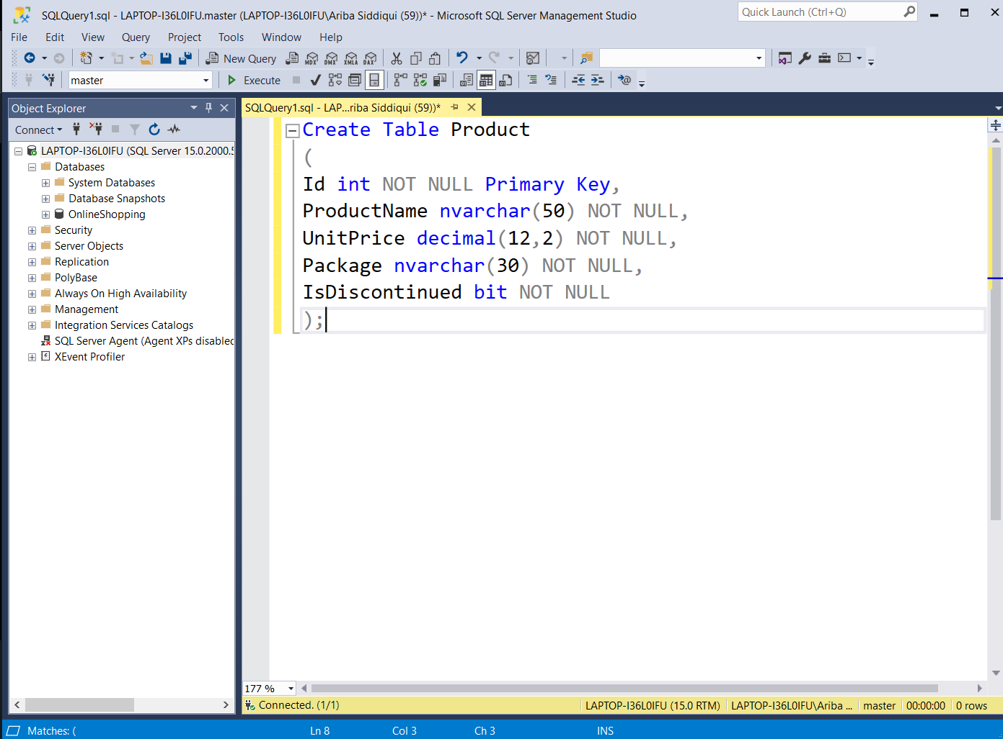

Create Table OrderTable

(

Id int NOT NULL Primary Key,

OrderDate datetime NOT NULL,

OrderNumber nvarchar(10) NOT NULL,

CustomerId int NOT NULL,

TotalAmount decimal(12,2) NOT NULL

);

Create Table Customer

(

Id int NOT NULL Primary Key,

FirstName nvarchar(40) NOT NULL,

LastName nvarchar(40) NOT NULL,

City nvarchar(40) NOT NULL,

Country nvarchar(40) NOT NULL,

Phone nvarchar(20) NOT NULL,

);

Create Table ProductSupply

(

Id int NOT NULL Primary Key,

CompanyName nvarchar(50) NOT NULL,

ContactName nvarchar(50) NOT NULL,

ContactTitle nvarchar(50) NOT NULL,

Country nvarchar(40) NOT NULL,

Phone nvarchar(20) NOT NULL,

City nvarchar(40) NOT NULL,

Fax nvarchar(30) NOT NULL

);

Alter Table Product ADD ProductSupplierId int NOT NULL

Alter Table OrderTable add constraint Order_CustomerId_FK

Foreign Key (CustomerId) references Customer(Id)

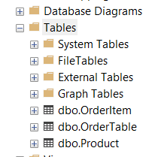

5.Display all customer details

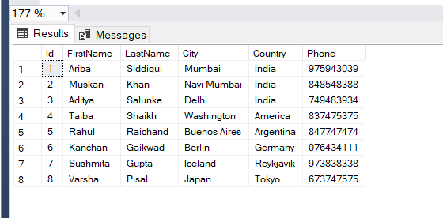

6.write a query to display Country whose name starts with A or I

Select * from Customer Where Country LIKE '[IA]%'

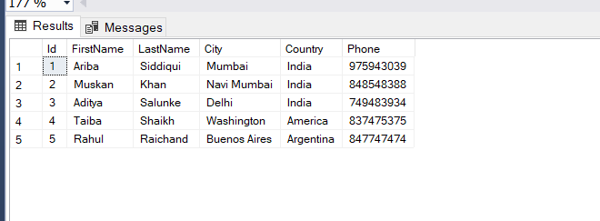

7 .write a query to display whose name of customer whose third character is i

Select * from Customer Where FirstName LIKE '__i%'

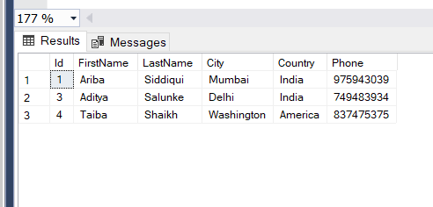

**Assignment No 2**

1. Display the details from Customer table who is from country Germany

Select * from Customer Where Country = 'Germany'

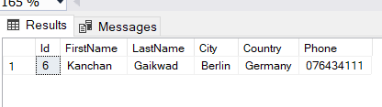

1. Display the fullname of the employee

SELECT emp_fullname FROM Employee

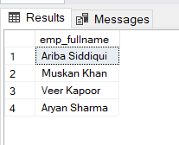

1. Display the customer details who has Fax number

Select * From Customer Where FaxNumber <> 'Null'

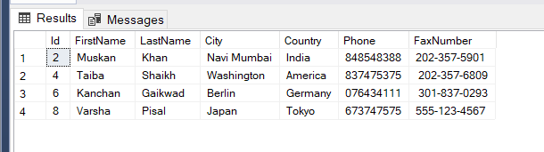

1. display the customer details whose name holds second letter as U

Select * from Customer Where FirstName LIKE '_u%'

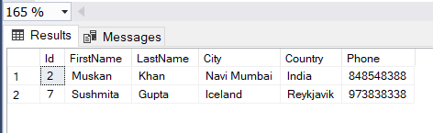

1. Select order Details where unit price is greater than 10 and less than 20

Select * from OrderItem Where UnitPrice > 10 AND UnitPrice < 20

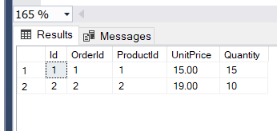

1. Display order details which contain shipping date and arrange the order by date

select OrderNumber,ShippingDate,UnitPrice,CustomerId

from OrderTable p

join OrderItem c

on p.Id= c.ProductId

order by ShippingDate asc

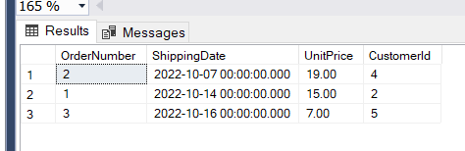

1. Print the orders shipped by ship name 'La corned'abondance' between 2 dates(Choose dates of your choice)

SELECT * FROM OrderTable

WHERE ShipName='Lacornedabondance'

SELECT * FROM OrderTable WHERE

OrderDate BETWEEN 06-10-2022 and 17-10-2022;

1. Print the products supplied by 'Exotic Liquids'

select ProductSupplierId,CompanyName,ProductName, Package

from

ProductSupply s join Product p

on(s.Id= p.ProductSupplierId) and s.CompanyName

IN('Exotic Liquids')

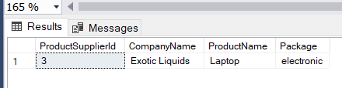

1. print the average quantity ordered for every product

select ProductName ,AVG(Quantity) as [Average Quantity]

from Product p join OrderItem o

on(p.Id=o.ProductId)

group by p.ProductName

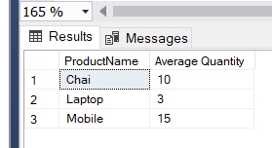

Select AVG(Quantity)as [Average Quantity] from OrderItem

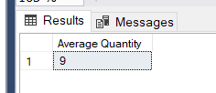

1. Print all the Shipping company name and the ship names if they are operational

Select CompanyName From ProductSupply

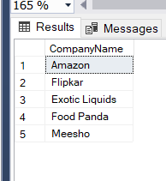

1. Print all Employees with Manager Name

SELECT emp_fullname, emp_manager FROM Employee

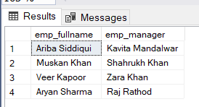

1. Print the bill for a given order id .bill should contain Productname, Categoryname,price after discount

SELECT ProductName ,(TotalAmount - OrderItem.Price )/TotalAmount * 100 as Discount

FROM OrderTable JOIN

OrderItem ON OrderTable.Id=OrderItem.OrderId

JOIN PRODUCT ON

OrderItem.ProductId=Product.Id

Where OrderTable.Id= 3

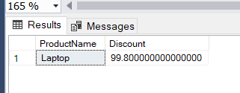

1. Print the Total price of orders which have the products supplied by 'Exotic Liquids' if the price is > 50 and also print it by Shipping company's Name

Select(OrderItem.Quantity*OrderItem.UnitPrice) as Total From OrderItem

Where Quantity*UnitPrice > 50

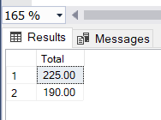

**Assignment No 3**

1.write a query to display the orders placed by customer with phone number 030-0074321

Select * from Customer Where Phone = '030-0074321'

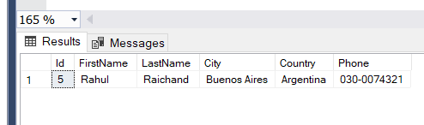

2.  Fetching all the products which are available under Category ‘Seafood’.

Select * from Product Where Package = 'Seafood'

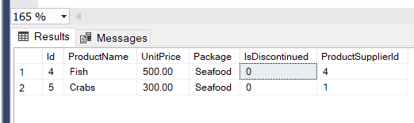

3.Display the orders placed by customers not in London

select FirstName as Custname,

OrderNumber,City,Country

from Customer c

join OrderTable o

on c.Id = o.CustomerId

where City != 'London'

group by

FirstName ,OrderNumber,City,Country

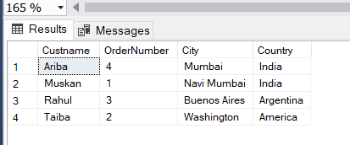

4. selects all the order which are placed for the product Chai.

select ProductName,

COUNT(ProductName) as [Oder placed for Chai],

OrderId,ProductId

from Product p

join OrderItem o

on p.Id = o.ProductId

where ProductName = 'Chai'

group by

ProductName,OrderId,ProductId

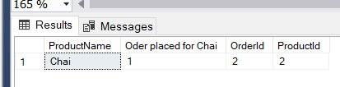

5.Write a query to display the name , department name and rating of any given employee

SELECT emp_fullname,emp_department,emp_rating FROM Employee Where emp_fullname = 'Ariba Siddiqui'

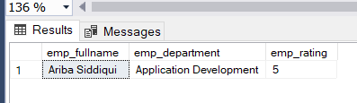

**Assignment No 4**

1. Print the Total price of orders which have the products supplied by 'Exotic Liquids' if the price is > 50 and also print it by Shipping company's Name

SELECT CompanyName,

TotalAmount FROM OrderTable JOIN OrderItem on OrderTable.Id = OrderItem.OrderId

JOIN ProductSupply ON

OrderItem.ProductId = ProductSupply.Id

WHERE CompanyName ='Exotic Liquids'AND TotalAmount>50

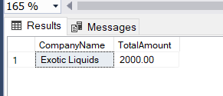

1. Display the employee details whose joined at first

Select * from Employee Where To_Char(emp_JoiningDate,'DD') = 01;

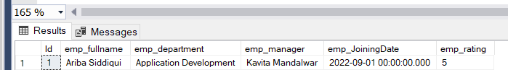

1. Display the employee details whose joined at recently

Select * from Employee order by emp_JoiningDate desc

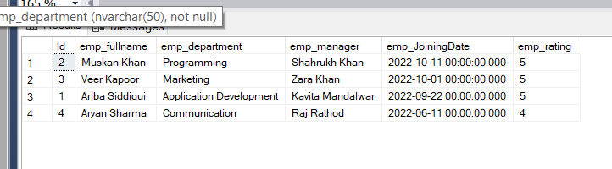

1. Write a query to get most expense and least expensive Product list (name and unit price).

Select ProductName , OrderItem.UnitPrice,

MAX(TotalAmount) as [Most Expensive Product],

MIN(TotalAmount) as [Least Expensive Product]

from OrderTable JOIN OrderItem on OrderTable.Id = OrderItem.OrderId

join Product on OrderItem.ProductId

= Product.Id

Group by ProductName, OrderItem.UnitPrice;

SELECT ProductName, ORDERITEM.UnitPrice,

MAX(TotalAmount) AS [Most Expensive], MIN(TotalAmount) As [Least Expensive]

FROM OrderTable INNER JOIN ORDERITEM ON OrderTable.Id=ORDERITEM.OrderId INNER JOIN PRODUCT ON ORDERITEM. ProductId=PRODUCT. Id

GROUP BY ProductName, ORDERITEM. UnitPrice;

1. Display the list of products that are out of stock

select ProductName as [Out of Stock Product] from Product where IsDiscontinued = 'True'

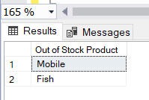

1. Display the list of products whose unitinstock is less than unitonorder

Select Min(OrderItem.UnitPrice) From OrderItem

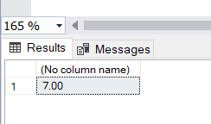

1. Display list of categories and suppliers who supply products within those categories

Select Package as Categories ,CompanyName as Supplier,

ProductName From Product Join

ProductSupply on Product.Id = Product.ProductSupplierId

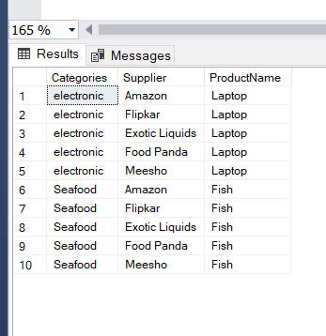

1. Display complete list of customers, the OrderID and date of any orders they have made

SELECT FirstName, LastName, City, Country, Phone, OrderDate ,OrderId

FROM Customer JOIN OrderTable ON

Customer.Id = OrderTable.CustomerId

Join OrderItem on OrderTable.Id = OrderItem.OrderId

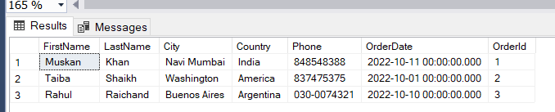

1. Write query that determines the customer who has placed the maximum number of orders

SELECT FirstName as CustomerName, Quantity as MaxOrderPlaced from Customer JOIN OrderTable ON

CUSTOMER.Id = OrderTable.CustomerId

INNER JOIN OrderItem On OrderTable.Id = OrderItem.OrderId

WHERE OrderItem.Quantity =( SELECT MAX(Quantity) FROM OrderItem)

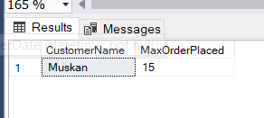

1. Display the customerid whose name has substring ‘RA’

select Id as CustomerID from Customer where FirstName like 'RA%'

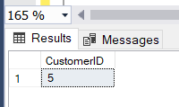

1. Display the first word of all the company name

SELECT SUBSTRING(CompanyName,1,1) as [First Letter of Company Name] from ProductSupply;

